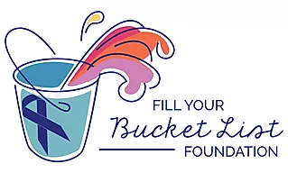
Fill Your Bucket List Foundation
P.O. Box 806
Cary, NC 27612

NEWS RELEASE

FOR IMMEDIATE RELEASE

April 24, 2020 CONTACT: Rachel HoTong, Public Relations Consultant
919-260-5555, rachel@fyblf.org

BUCKET BASH FUNDRAISING GALA MOVED ONLINE

CARY, N.C. – The Bucket Bash, local nonprofit Fill Your Bucket List Foundation’s annual fundraising gala, has been cancelled in response to the COVID-19 outbreak. The Bucket Bash will now be held online through Zoom on June 12, 2020 at 7 p.m.
Founded in 2014, Fill Your Bucket List Foundation grants lifelong wishes to adult cancer patients and their families. The annual gala is the organization’s largest source of donations.
As a nonprofit, the Foundation relies on donors contributions. In light of recent economic crisis, the organization understands that its previous donors may be in a different financial situation than when they previously contributed.
“We are 100 percent dependent on other people’s generosity,” said founder Peggy Gibson Carroll said.
-MORE-

BUCKET BASH/Page 2
The virtual Bucket Bash will auction off items such as Angus Barn gift cards, spa retreats, and a basketball signed by the UNC-Chapel Hill basketball team.
The Foundation plans to use the money raised at the auction to provide wishes to as many cancer patients as possible once travel restrictions are lifted.
###
About Fill Your Bucket List Foundation
Fill Your Bucket List Foundation is a nonprofit that provides funding to adults (18+) with cancer to make their dream come true. The Foundation fundraises through events including its annual gala, The Bucket Bash. Founded by Peggy Gibson Carroll, who encouraged her father to create a bucket list after he was diagnosed with cancer, Fill Your Bucket List Foundation strives to remove any obstacle that may hinder families from making memories together. To learn more, visit www.fillyourbucketlistfoundation.org.

