Fill Your Bucket List Foundation
P.O. Box 806
Cary, NC 27512
PROFILE
April 24, 2020 CONTACT: Rachel HoTong, Public Relations Coordinator
919-260-5555, rphotong@live.unc.edu

CARY, N.C. – “In his mind, the bucket list was done,” Peggy Gibson-Carroll said as she recalled the final moments of her father’s life. After Gibson-Carroll’s father was diagnosed with late-stage lung cancer, the Chapel Hill native asked her father what was on his bucket list.
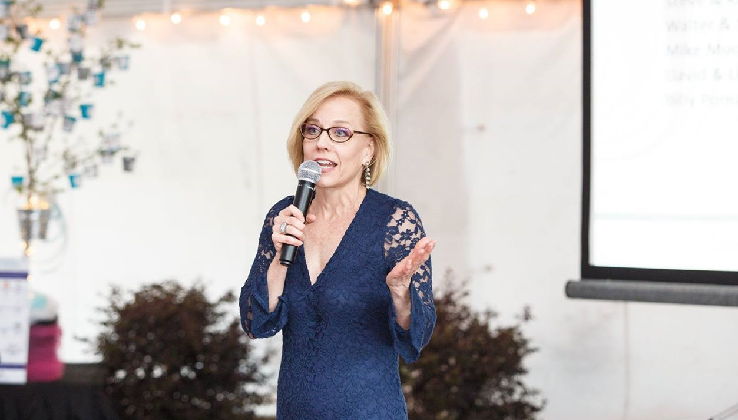
Peggy Gibson-Carroll at Fill Your Bucket List’s Second Annual Bucket Bash. Photo Courtesy of FYBLF.
With 30 years of experience as an oncology patient advocate, Gibson-Carroll understood she did not have much time left with her father.
-MORE-

BUCKET LIST/Page 2
Her father’s only request was to attend the rest of his grandchildren’s band competitions. She coordinated with the band director, who supported the idea. The band director arranged for Gibson-Carroll’s father to enjoy the performances while sitting right in the middle of the band.
“The day after the last band competition, he passed away,” Gibson-Carroll said while holding back tears. After seeing the peace her father had after checking off the last item on his bucket list, she went to his doctor at UNC Hospitals.
“I have this crazy idea,” Gibson-Carroll said to her father’s doctor. “I want to start a foundation. I want to do this for other people.”
The doctor connected her with Yolanda, a single mother who has been battling cancer for 15 years. Gibson-Carroll and her husband decided to use their vacation funds to send Yolanda and her family on a Disney Cruise to the Caribbean.
“That was wish number one,” she said. The oncology patient advocate proceeded to establish the Fill Your Bucket List Foundation to give adult cancer patients and their families memories that will last a lifetime.
The nonprofit has granted over 150 wishes and touched over 900 lives. The families served in each wish is counted as “lives touched.” Gibson-Carroll believes that the families greatly benefit from the wishes since they have the memories and photos to hold on to.
“For a brief moment, they forget they have cancer,” Gibson-Carroll said through a joyful smile. “They have something to look forward to at the end of their treatment.”
-MORE-

BUCKET LIST/Page 3
Gibson-Carroll said that the mind and mental health are an important part of the journey. “We’ve seen some patients have a complete turnaround,” she said while recounting
previous wish recipients’ health after their wish.
The Foundation currently gives priority to North Carolina residents, however Gibson-Carroll dreams of Fill Your Bucket List to be operating in every state. “Our dream is to do what we do well in North Carolina and partner with cancer centers and serve as many patients locally,” the founder said. The organization is structured to be a model for people to duplicate in other states.
Her father got to check off everything on his bucket list. Gibson-Carroll’s bucket list is to serve as many cancer patients as she can. “Nobody knows what our time table is,” Gibson-Carroll said, “and the proudest moment [in the organization] is every wish.”
###

