Social Media Content Guide
Colors & Code
F4cf53 f1543d dd256b d16abb 4e91bb 78bcbf 282e7b


- Inspirational Quotes (click me for a free, editable template!)
- Having a clean, bright aesthetic produces a sense of hope and joy.
PRO TIP: Consistently use the same colors for the same themed post
  - Ex) Light blue & yellow = quotes
  - Ex) Orange = helpful tips
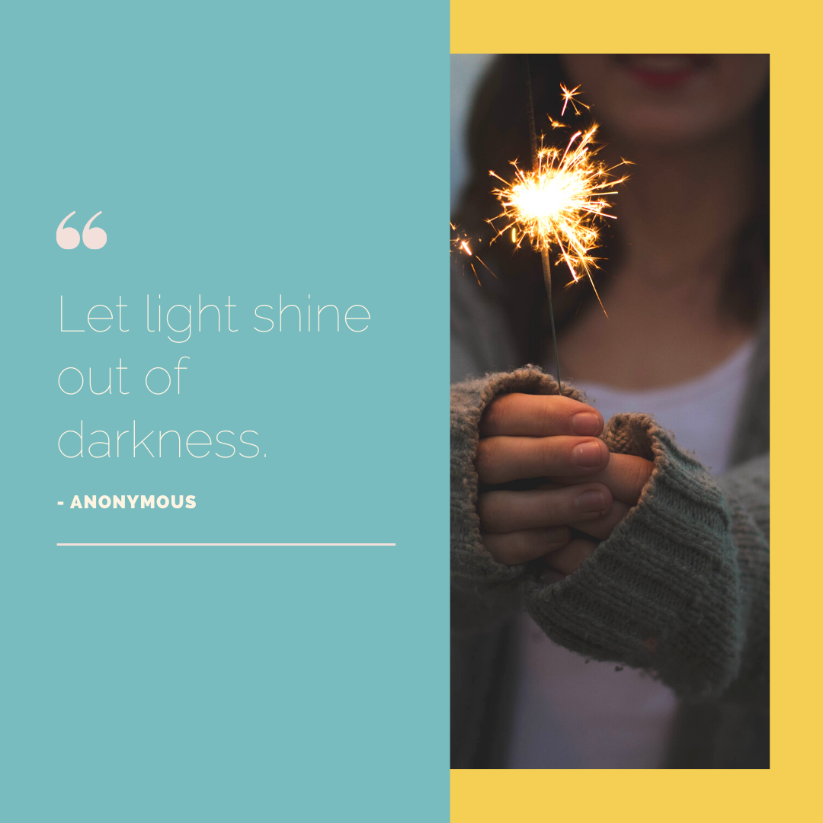
-MORE-

- Start a weekly campaign (click me for a free, editable template!)
- The best way to attract and maintain followers is to post content that brings them value (not just showing off what we’re doing)
- Tip Tuesday, Fact Friday, Bucket List Monday, etc. 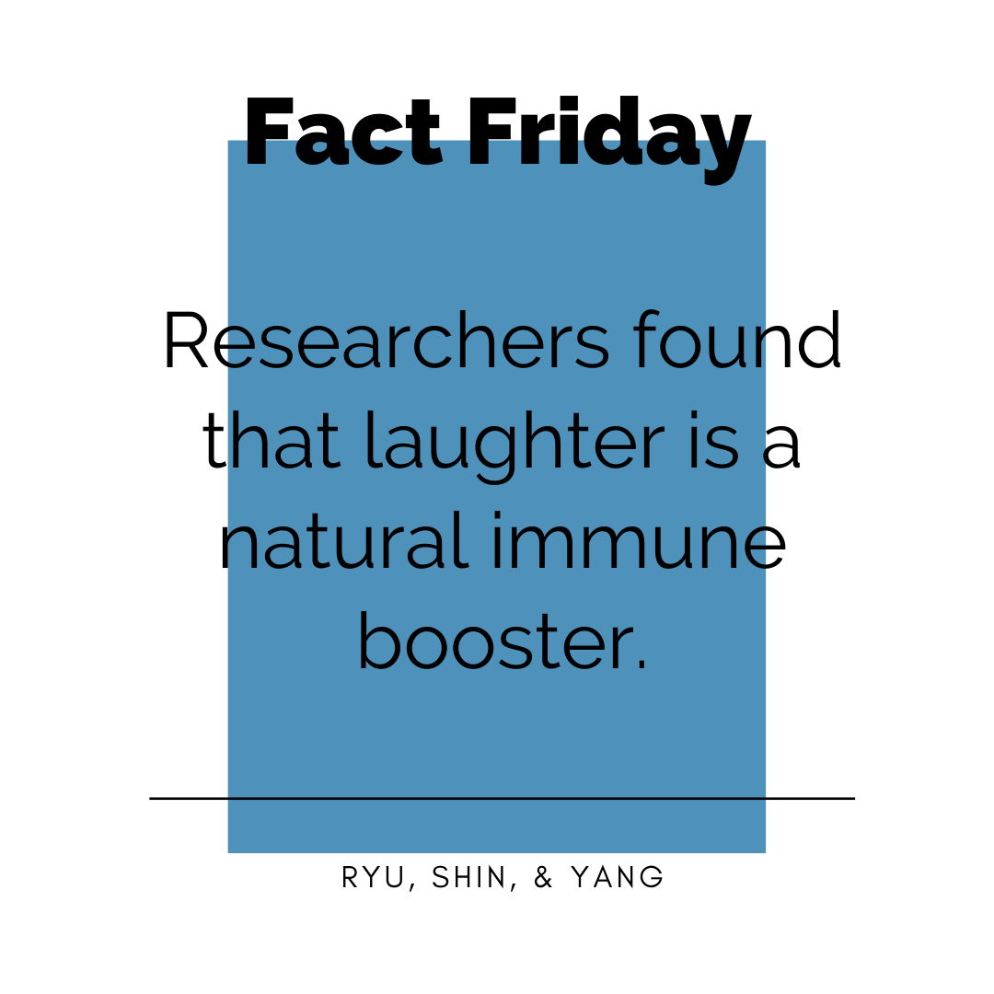
- Don’t be afraid of white space (click me for a free, editable template!)

- Creating negative space on your page will make the images of people pop!

-MORE-
- Post videos and boomerangs
- Videos humanize people even more than photos! Take boomerangs of wish recipients and families waving goodbye before they go off on their trip!
- Have a giveaway
- Encourage people to tag their friends on a post, repost your post to their stories, make a post and tag FYBLF, use a hashtag, etc.
- Ex) Kindness Challenge: Post a photo of an act of kindness you did, tag us in it, and enter to win ____!
- Use a filter
- Avoid dark, fake, grainy filters. Be careful of having too much contrast
- Select bright, color-popping filters
- Filters bring consistency and add a professional aesthetic to your page

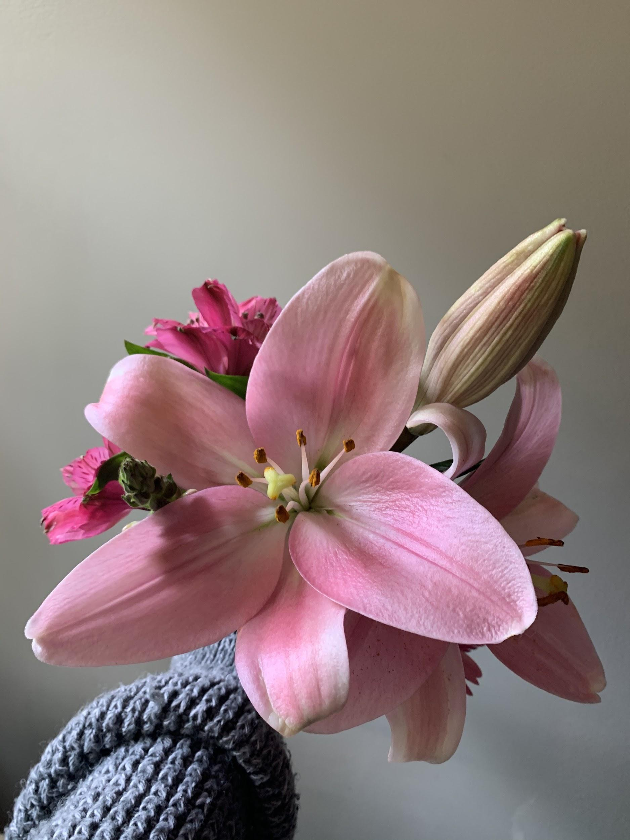


Unedited



Edited using
Color Story app,
Filter “Lite Bright”

